Supporting Tables Required for Submission:
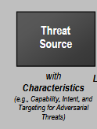

Table D-7: Identification of Adversarial Threat Sources
Identifier | Threat Source | Source of Information | In Scope | Capability | Intent | Targeting
1
2
…

Table D-8: Identification of Non-Adversarial Threat Sources
Identifier | Threat Source | Threat Source Type | In Scope | Range of Effects
1
2
…

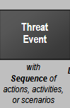
Table E-5: Identification of Threat Events for Adversarial Risk
Identifier | Threat Event | Source of Information | Threat Source | Relevance
1
2
…

Table E-5: Identification of Threat Events for Non-Adversarial Risk
Identifier | Threat Event | Source of Information | Threat Source | Relevance
1
2
…
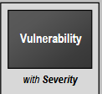
TABLE F-3: TEMPLATE – IDENTIFICATION OF VULNERABILITIES
Identifier | Vulnerability | Vulnerability Severity
1
2
…

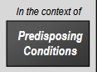
TABLE F-6: TEMPLATE – IDENTIFICATION OF PREDISPOSING CONDITIONS
Identifier | Predisposing Condition | Pervasiveness of Condition
1
2
…
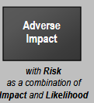
TABLE H-4: IDENTIFICATION OF ADVERSE IMPACTS
Type of Impact | Impact | Affected Asset | Maximum Impact
Financial
Operational
Reputational
Legal/Compliance
Data Integrity
Privacy
Service Availability
Environmental

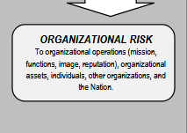
TABLE I-5: ADVERSARIAL RISK
Identifier | 1 | 2 | 3 | 4 | 5 | 6 | 7 | 8
Identifier | Threat Event | Threat Sources | Threat Source Characteristics |  |  | Relevance | Likelihood of Attack Initiation | Vulnerabilities and Predisposing Conditions
Identifier | Threat Event | Threat Sources | Capability | Intent | Targeting | Relevance | Likelihood of Attack Initiation | Vulnerabilities and Predisposing Conditions
1
2
…

9 | 10 | 11 | 12 | 13
Severity and Pervasiveness | Likelihood Initiated Attack Succeeds | Overall Likelihood | Level of Impact | Risk
…

Table I-7: Template – Non-Adversarial Risk
Identifier | 1 | 2 | 3 | 4 | 5 | 6
Identifier | Threat Event | Threat Sources | Range of Effects | Relevance | Likelihood of Event Occurring | Vulnerabilities and Predisposing Conditions
1
2

7 | 8 | 9 | 10 | 11
Severity and Pervasiveness | Likelihood Event Results in Adverse Impact | Overall Likelihood | Level of Impact | Risk

